**CONSTRUCTION下有一个空**

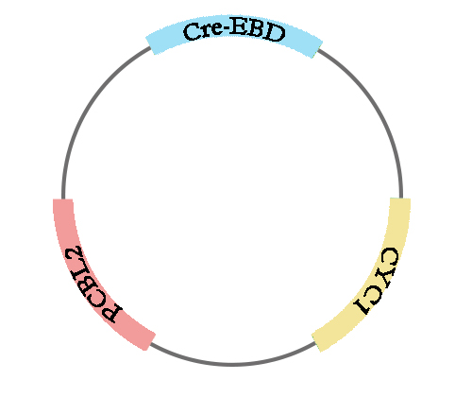

原图和改过尺寸之后是同一个（因为这个图是曼琳做的，只有一个版本）：<http://2017.igem.org/wiki/images/d/d5/TJU-scramble1.jpeg>

Figure 1. This is a simplified version of this vector expressing the Cre recombinase enzyme. CRE-EBD is the coding sequence of Cre recombinase; PCLB2 is a constitutive promoter in yeast; CYC1 is a terminator.

**Dilution Assay下面第一个空**

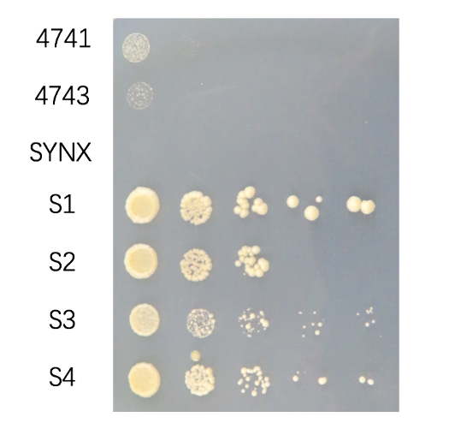

改过尺寸之后：<http://2017.igem.org/wiki/images/5/5e/TJU-scramble_figure2.jpeg>

原图：http://2017.igem.org/wiki/images/d/d0/TJU-S-figure_2_yuan.png

Figure 2. Experimental groups: S1, S2, S3, and S4; control groups: *synX*, *BY474,* and *BY4743*. Yeast cells were picked up from single colonies on solid growth media and diluted by 10, 100, 1000, 10000, and 100000 times.

**Dilution Assay下面第二个空**

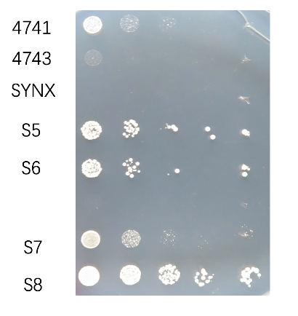

改过尺寸之后：http://2017.igem.org/wiki/images/1/11/TJU-scramble_figure_3.jpeg

原图：<http://2017.igem.org/wiki/images/f/fe/TJU-S_figure_3_yuan.png>

Figure 3. Experimental groups: S5, S6, S7, and S8; control groups: *synX*, *BY4741,* and *BY4743*. Yeast cells were picked up from single colonies on solid growth media and diluted by 10, 100, 1000, 10000, and 100000 times.

**Survival Rate** **Experiments 下第一个空.有3个图哦~**

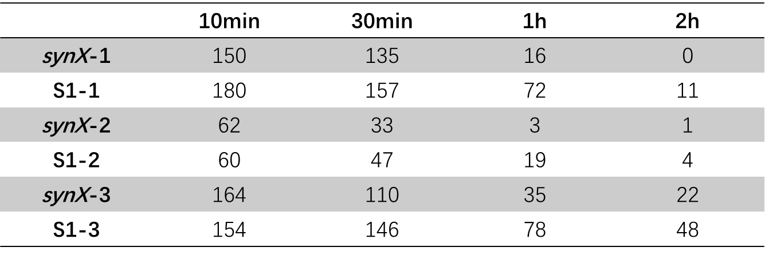

改过尺寸之后：http://2017.igem.org/wiki/images/6/64/TJU-scramble_table_1.png

原图：http://2017.igem.org/wiki/images/9/9d/TJU-S_table_1_yaun.png

Table 1. Colony numbers of *synX* and S1. Experiments were repeated for three times.

Cadmium concentration: 5mM for the first and the third experiments; 10 mM for the second experiment.

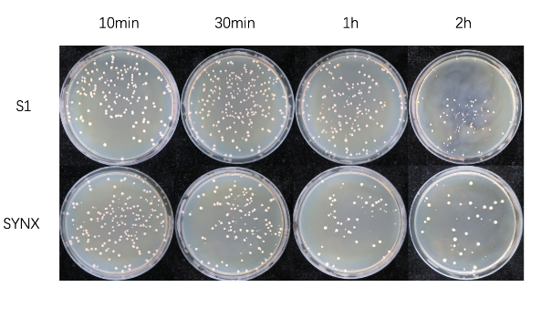

改过尺寸之后：http://2017.igem.org/wiki/images/1/1a/TJU-scramble_figure_4.jpeg

原图：http://2017.igem.org/wiki/images/2/25/TJU-S_figure_4_yuan.png

Figure 4. Picture of the third survival rate experiment results. Growth media: YPD. Experimental strain: S1; control strain: *synX*. Cells were plated onto the media after immersed in 5 mM cadmium solution for 10 minutes, 30minutes, 1 hour, and 2hours.

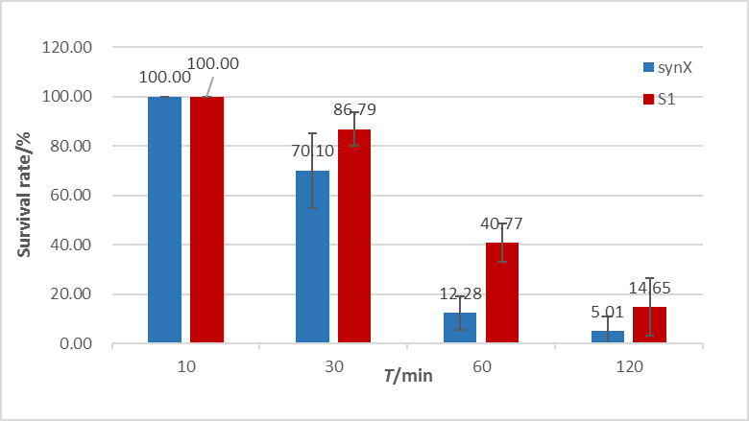

改过尺寸之后：

Figure 5. Survival rates of *synX* and S1 in cadmium ion solution. In order to eliminate the error brought by the different amount of cells picked up from the media, the survival rate equals the value of the number of the colonies developed on growth media after immersed in cadmium solution for a certain amount of time divided by that of the colonies developed on growth media after immersed in cadmium solution for 10 minutes. Mean values are shown in the graph. The error line stands for the standard deviation.

**Survival Rate Experiments 下第二个空**

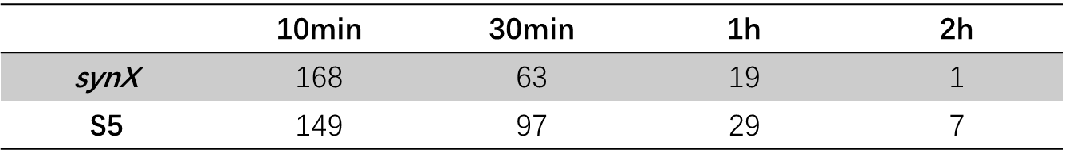

改过尺寸之后：http://2017.igem.org/wiki/images/e/ee/TJU-scramble_table_2.png

原图：http://2017.igem.org/wiki/images/c/cf/TJU-S_table_2_yuan.png

Table 2. Colony numbers of *synX* and S5. Due to the time limit, we conducted this experiment for only one time. Yeast cells were immersed in 50mM copper solutions for 10 minutes, 30 minuets, 1 hour, and 2 hours.

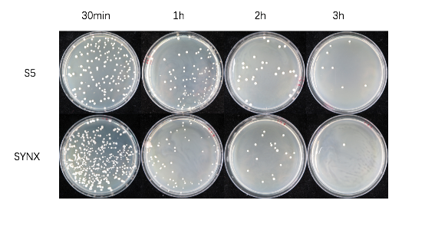

改过尺寸之后：http://2017.igem.org/wiki/images/c/c2/TJU-scramble_figure_6.png

原图：http://2017.igem.org/wiki/images/3/3e/TJU-S_figure_6_yuan.png

Figure 6. Picture of survival rate experiment results. Growth media: YPD. Experimental strain: S5; control strain: *synX*. Cells were plated onto the media after immersed in 50 mM copper solution for 10 minutes, 30minutes, 1 hour, and 2hours.

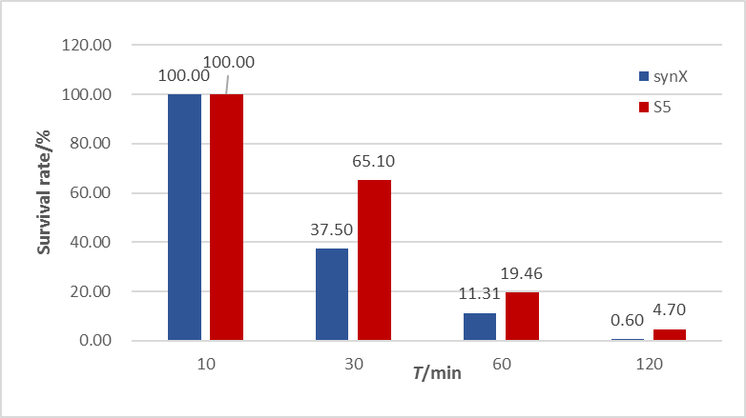

Figure 7. Survival rates of *synX* and S5 in copper solution. In order to eliminate the error brought by the different amount of cells picked up from the media, the survival rate equals the value of the number of the colonies developed on growth media after immersed in copper solution for a certain amount of time divided by that of the colonies developed on growth media after immersed in copper solution for 10 minutes. Mean values are shown in the graph. The error line stands for the standard deviation.